MessageMapping demo for API Access

[Iliya.kuznetsov@gmail.com](mailto:Iliya.kuznetsov@gmail.com) (ILIYA KUZNETSOV)

1. Make imported archive:  
   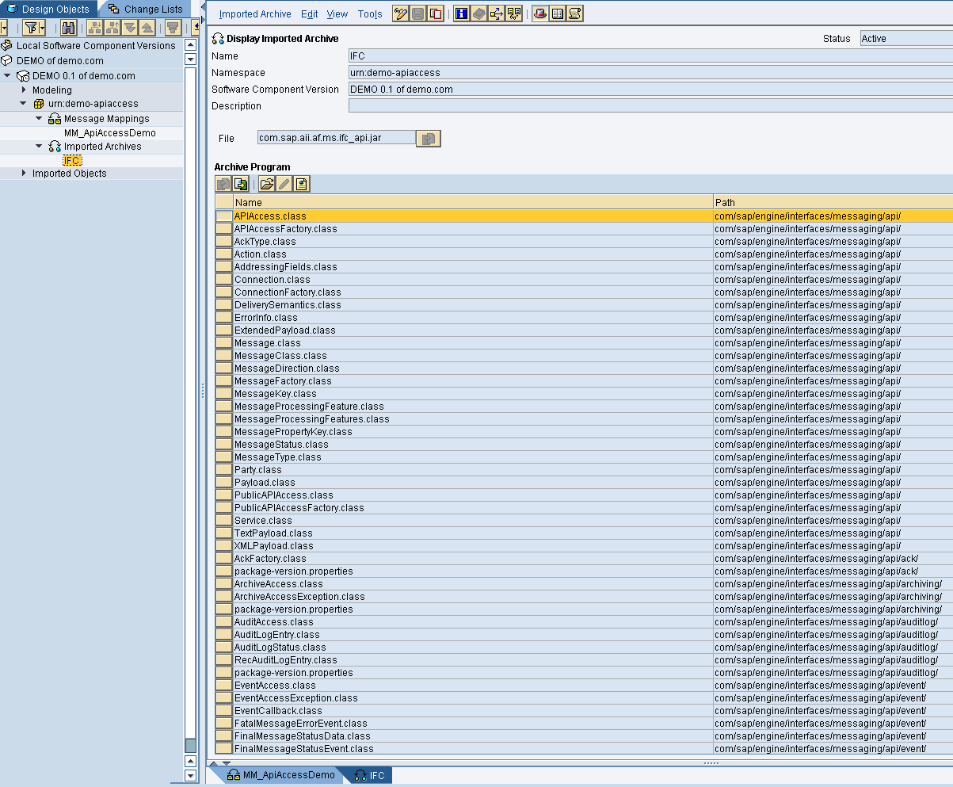
2. Make message mapping as follows:

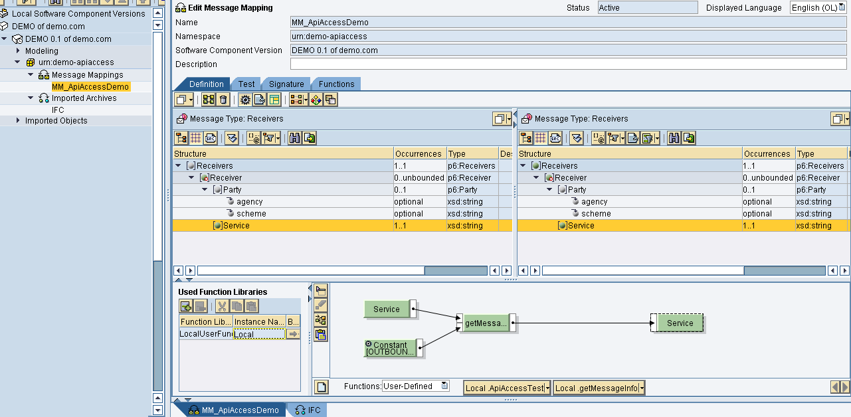

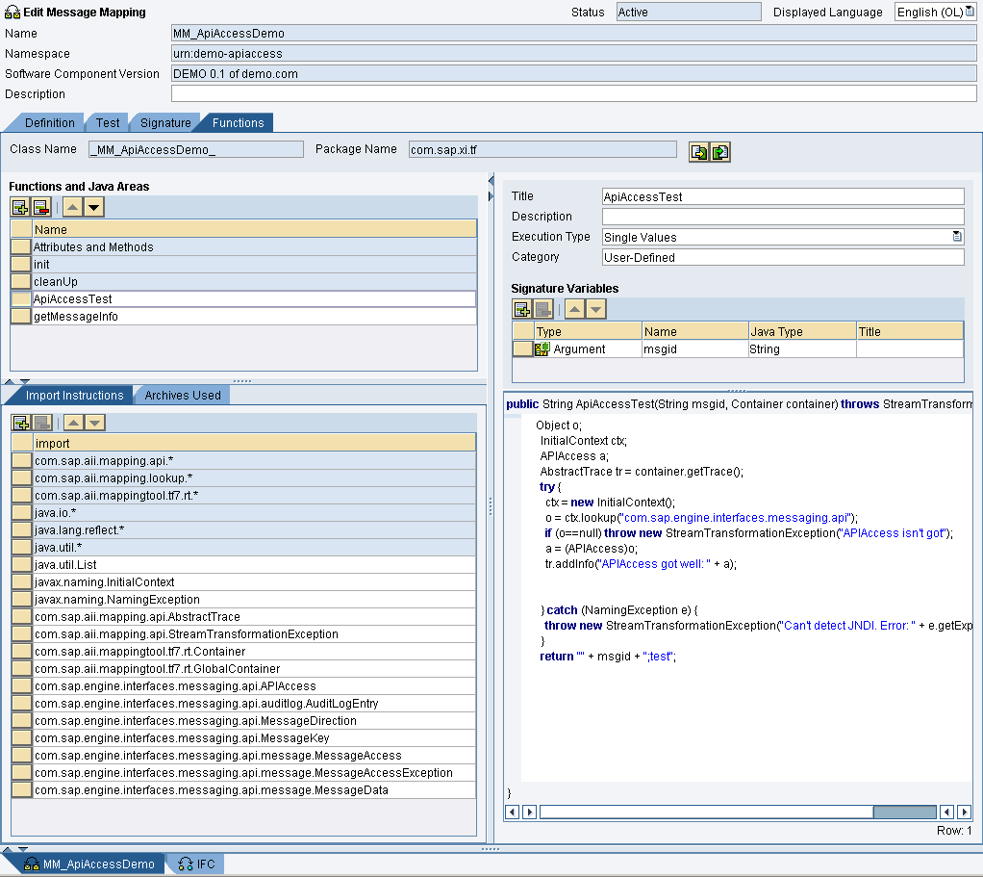

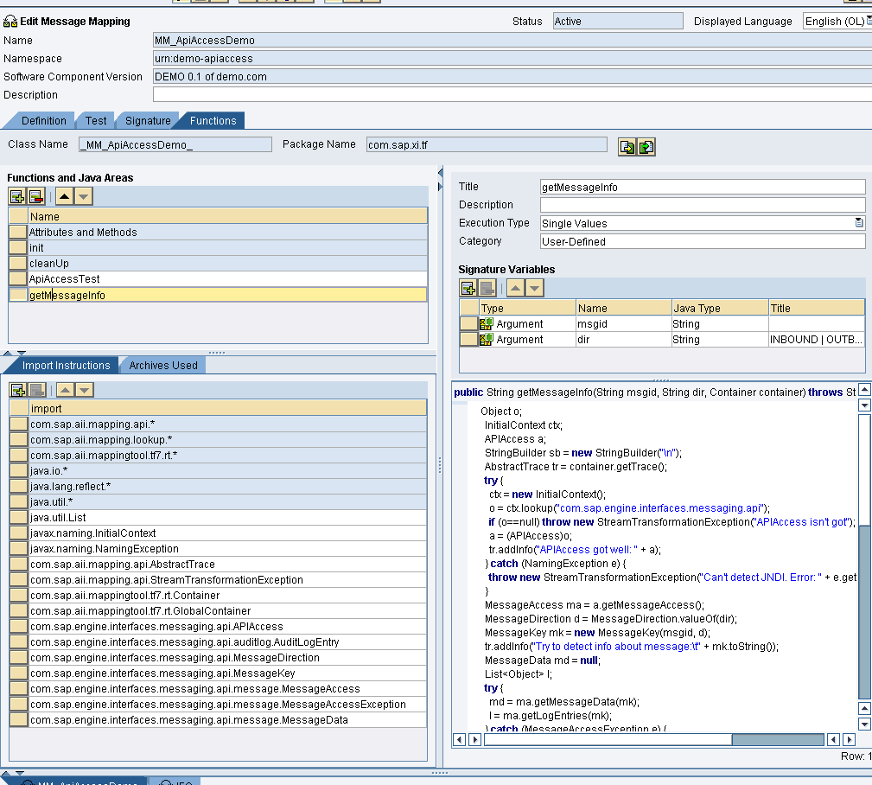

Take code from _MM_ApiAccessDemo_.java

Then, find any messageId from /pimon and post it into test sample:

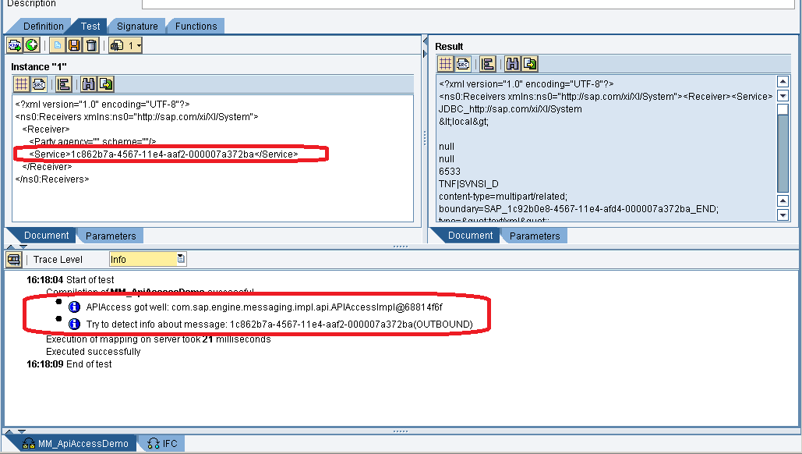

After that, you’ll get something like that:

<?xml version="1.0" encoding="UTF-8"?>

<ns0:Receivers xmlns:ns0="http://sap.com/xi/XI/System"><Receiver><Service>

JDBC_http://sap.com/xi/XI/System

&lt;local&gt;

null

null

6533

XXX|XXXXXXXX_D

content-type=multipart/related; boundary=SAP_1c92b0e8-4567-11e4-afd4-000007a372ba_END; type=&quot;text/xml&quot;; start=&quot;&lt;soap-1c92b0e7456711e49591000007a372ba@sap.com&gt;&quot;

http=POST

content-length=6533

S 2014-09-26 14:23:09 JDBC_SUC_004 CC_BankPair_JDBC_Send,null,null,null,null,

S 2014-09-26 14:23:09 JDBC_SUC_005 CC_BankPair_JDBC_Send,1,null,null,null,

S 2014-09-26 14:23:09 JDBC_SUC_009 3478,null,null,null,null,

S 2014-09-26 14:23:09 MP: processing local module {0} localejbs/CallSapAdapter,null,null,null,null,

S 2014-09-26 14:23:09 SEND_TRYING JDBC_http://sap.com/xi/XI/System,XI,null,null,null,

S 2014-09-26 14:23:09 SEND_QUEUE_PUT_TRYING null,null,null,null,null,

S 2014-09-26 14:23:09 QUEUE_PUT_SUCCESS null,null,null,null,null,

S 2014-09-26 14:23:09 SEND_SUCCESS JDBC_http://sap.com/xi/XI/System,null,null,null,null,

S 2014-09-26 14:23:09 SEND_QUEUE_GET_SUCCESS null,null,null,null,null,

S 2014-09-26 14:23:09 STATUS_SET_SUCCESS DLNG,null,null,null,null,

S 2014-09-26 14:23:09 SEND_QUEUE_PUT_TRYING null,null,null,null,null,

S 2014-09-26 14:23:09 QUEUE_PUT_SUCCESS null,null,null,null,null,

S 2014-09-26 14:23:09 SEND_QUEUE_GET_SUCCESS null,null,null,null,null,

S 2014-09-26 14:23:09 STATUS_SET_SUCCESS DLNG,null,null,null,null,

S 2014-09-26 14:23:09 SEND_QUEUE_PUT_TRYING null,null,null,null,null,

S 2014-09-26 14:23:09 QUEUE_PUT_SUCCESS null,null,null,null,null,

S 2014-09-26 14:23:09 SEND_QUEUE_GET_SUCCESS null,null,null,null,null,

S 2014-09-26 14:23:09 STATUS_SET_SUCCESS DLNG,null,null,null,null,

S 2014-09-26 14:23:09 AAE_REQUEST_MAPPING urn:mapping:001BankImport:SVNSI,BankPairNotification__BankProxyNotification,cbf5bad0b0be11e29710cb3b0a0000fe,null,null,

S 2014-09-26 14:23:09 AFW_DELIVER CC_JPR_Recv,null,null,null,null,

S 2014-09-26 14:23:09 MP: processing local module {0} localejbs/sap.com/com.sap.aii.af.soapadapter/XISOAPAdapterBean,null,null,null,null,

S 2014-09-26 14:23:09 XI packaging (bulk mode) is not enabled. Switching to normal processing.... null,null,null,null,null,

S 2014-09-26 14:23:09 XISOAP: XI message received for processing null,null,null,null,null,

S 2014-09-26 14:23:09 SOAP: Request message entering the adapter processing with user j2ee_gst_jxd null,null,null,null,null,

S 2014-09-26 14:23:09 REQUEST XI,http://localhost:51200/MessagingSystem/receive/JPR/XI,User,PIAPPLJXD2,null,

S 2014-09-26 14:23:09 RECEIVE_QUEUE_PUT_TRYING JPR,null,null,null,null,

S 2014-09-26 14:23:09 QUEUE_PUT_SUCCESS null,null,null,null,null,

S 2014-09-26 14:23:09 RECEIVE_QUEUE_GET_SUCCESS null,null,null,null,null,

S 2014-09-26 14:23:09 SOAP: Processing completed null,null,null,null,null,

S 2014-09-26 14:23:09 STATUS_SET_SUCCESS DLNG,null,null,null,null,

S 2014-09-26 14:23:09 SEND_TRANSMIT_SUCCESS JDBC_http://sap.com/xi/XI/System,&lt;local&gt;,null,null,null,

S 2014-09-26 14:23:09 JPR_IN_ACCEPTED null,null,null,null,null,

S 2014-09-26 14:23:09 STATUS_SET_SUCCESS DLVD,null,null,null,null,

S 2014-09-26 14:23:09 Calling Invoke Method null,null,null,null,null,

S 2014-09-26 14:23:11 Back after executing Invoke Method null,null,null,null,null,

S 2014-09-26 14:23:11 JPR_IN_PROCESS_SUCCESS null,null,null,null,null,

S 2014-09-26 14:23:11 RECEIVE_DELIVER_SUCCESS JPR,null,null,null,null,

S 2014-09-26 14:23:11 STATUS_SET_SUCCESS DLVD,null,null,null,null,

</Service></Receiver></ns0:Receivers>